PROJECT INTERCOMPUTE: INDIVIDUAL RESEARCH CONTRIBUTION
Specialized Technical Dossier — Rishabh Ladha (Registration No: 12317813)
Student Researcher: Rishabh Ladha (Reg: 12317813) | Architectural Specialization: UI/UX & Provider Portal | Scientific Citation Fact-Checking Specialist
Core Codebase Modules: Provider Interface, Telemetry Displays, Literature Audit | Work Month: October 2026
Project Title: InterCompute: A Resilient Peer-to-Peer Compute Marketplace | Core Engine: GhostInTheMachine (Risk-Aware DAG Scheduler)

1. Executive Technical Summary & Individual Research Scope
Individual Contribution: My individual contributions focused on: (1) Designing the Provider-Side Portal Architecture and Owner-Aware Computing Interfaces, enabling everyday laptop and PC owners to lease spare compute capacity without compromising their personal device experience; and (2) Rigorous Academic Literature Fact-Checking, screening related work on volunteer computing and live VM migration to purge flawed assumptions and inaccurate citations from our technical documentation.
2. Capstone Project Vision: InterCompute vs. Existing Products (Vast.ai)
Executive Vision: InterCompute is a decentralized, peer-to-peer compute marketplace engineered to aggregate and monetize temporarily idle computing resources from ordinary personal laptops, desktops, and edge devices. Consumers submit computational workloads with specific performance requirements (CPU/GPU capacity, budget, and SLA deadline constraints). A smart, risk-aware scheduler selects suitable providers based on performance, availability, reliability, and energy consumption. Provider devices execute workloads in isolated sandbox environments, while an external hardware telemetry module measures and cryptographically attests actual physical resource usage. Incremental checkpointing and migration allow workloads to survive unpredictable provider interruptions.
2.1 Existing Market Benchmark: The Vast.ai Model
Vast.ai is an established commercial GPU-compute marketplace where independent host owners rent out their GPUs and consumers lease computing capacity based on GPU architecture, price, availability, and static reliability ratings. However, Vast.ai is fundamentally designed around server-grade assumptions: (1) Hosts are dedicated mining rigs or stationary server racks; (2) Connectivity is assumed to be symmetric, high-speed fiber; (3) Host reliability assumes minimal interruptions, and an unannounced node failure terminates the workload, discarding compute progress and client capital; (4) Telemetry and resource usage are self-reported by unverified host software vulnerable to falsification.
2.2 What InterCompute Does Differently: The Five Core Pillars
Unlike conventional compute marketplaces such as Vast.ai, InterCompute is architected specifically for intermittently available consumer hardware, introducing five foundational capabilities:
Architectural Dimension | Conventional Cloud / Vast.ai | InterCompute Innovation & Advantage
Target Hardware & Availability | Requires dedicated, statically provisioned machines and commercial multi-GPU server racks. | Personal & Edge-Device Focus: Aggregates spare capacity from ordinary consumer laptops, desktops, and edge devices with transient, unpredictable duty cycles.
Device Owner Priority | Host machine is fully leased to renter. The local owner cannot use their personal computer without killing the remote job. | Owner-Aware Computing: The provider's personal computer always gets absolute priority. Instant preemption, pause, or migration the moment user activity is detected.
Trust & Metric Integrity | Software-only self-reporting. Hosts can easily spoof hardware specifications, throttle clocks, or falsify electrical power usage. | Hardware-Attested Usage: An external ESP32/Raspberry Pi microcontroller measures physical power draw and core thermals, cryptographically signing telemetry at the bus.
Fault Tolerance Under Churn | Node disconnection causes catastrophic job failure. Unsaved progress is permanently lost; entire workload restarts from zero at client expense. | Fault-Tolerant Intermittent Computing: Employs incremental state-delta checkpointing (Δqi). Surviving replacement peers resume execution in ~5.3s.
Network Modeling | Assumes high symmetric bandwidth. Communication grinds to a halt on consumer residential broadband. | Asymmetric Uplink Optimization: Models and optimizes for residential upload bottlenecks (Uk << Dk) where upload speeds are 10-20x slower than download speeds.
Scheduling Intelligence | Simple price and static benchmark matching. Blind to preemption hazard rates, session wear-out, and thermal fatigue. | Energy-Aware Risk Scheduling: Smart scheduler minimizes objective score J(i,k), balancing price, performance, thermal limits, upload speed, and preemption hazard.

3. Owner-Aware Computing & Preemption Interception Algorithm
The fundamental requirement for provider adoption is non-intrusive computing. When an owner moves their mouse or launches an application, the guest task must yield local CPU cores instantly. I engineered the Owner Preemption Daemon logic:
ALGORITHM: OwnerActivityInterceptionDaemon(Threshold idle_time_sec, CoreQuota max_cpu)
Input: Local provider activity hooks (keyboard/mouse interrupt signals), Thermal limit T_max
Output: Real-time compute execution state (RUNNING, PAUSED, MIGRATING)

1: Initialize LocalState <- IDLE, IdleTimer <- 0
2: Loop continuously at 100ms polling interval do
3: HardwareActivity <- ReadOSInputEvents()
4: CurrentTemp <- ReadHardwareTemperatureSensor()
5: If HardwareActivity is TRUE then
6: // Owner has returned to their personal computer
7: If LocalState == RUNNING then
8: SignalTaskExecutionThread(SIGSTOP)
9: LocalState <- PAUSED
10: TriggerInstantCheckpointCommit(delta_mode=TRUE)
11: NotifySchedulerNodeStatus(node_id, status='OWNER_PREEMPTED')
12: End If
13: IdleTimer <- 0
14: Else
15: IdleTimer <- IdleTimer + 0.1
16: If (IdleTimer >= idle_time_sec) and (CurrentTemp < T_max) and (LocalState != RUNNING) then
17: // System is safely idle; resume background guest execution
18: SignalTaskExecutionThread(SIGCONT)
19: LocalState <- RUNNING
20: NotifySchedulerNodeStatus(node_id, status='AVAILABLE')
21: End If
22: End If
23: End Loop

4. Real-Time Hardware Telemetry Visualization Dashboard
I designed the provider desktop UI containing live streaming gauges: (1) Core Power (Watts) sampled at 1.0 Hz from the ESP32; (2) Thermal Headroom (°C); (3) Upstream and downstream bandwidth utilization; and (4) Cumulative earnings ledger credited in real time.
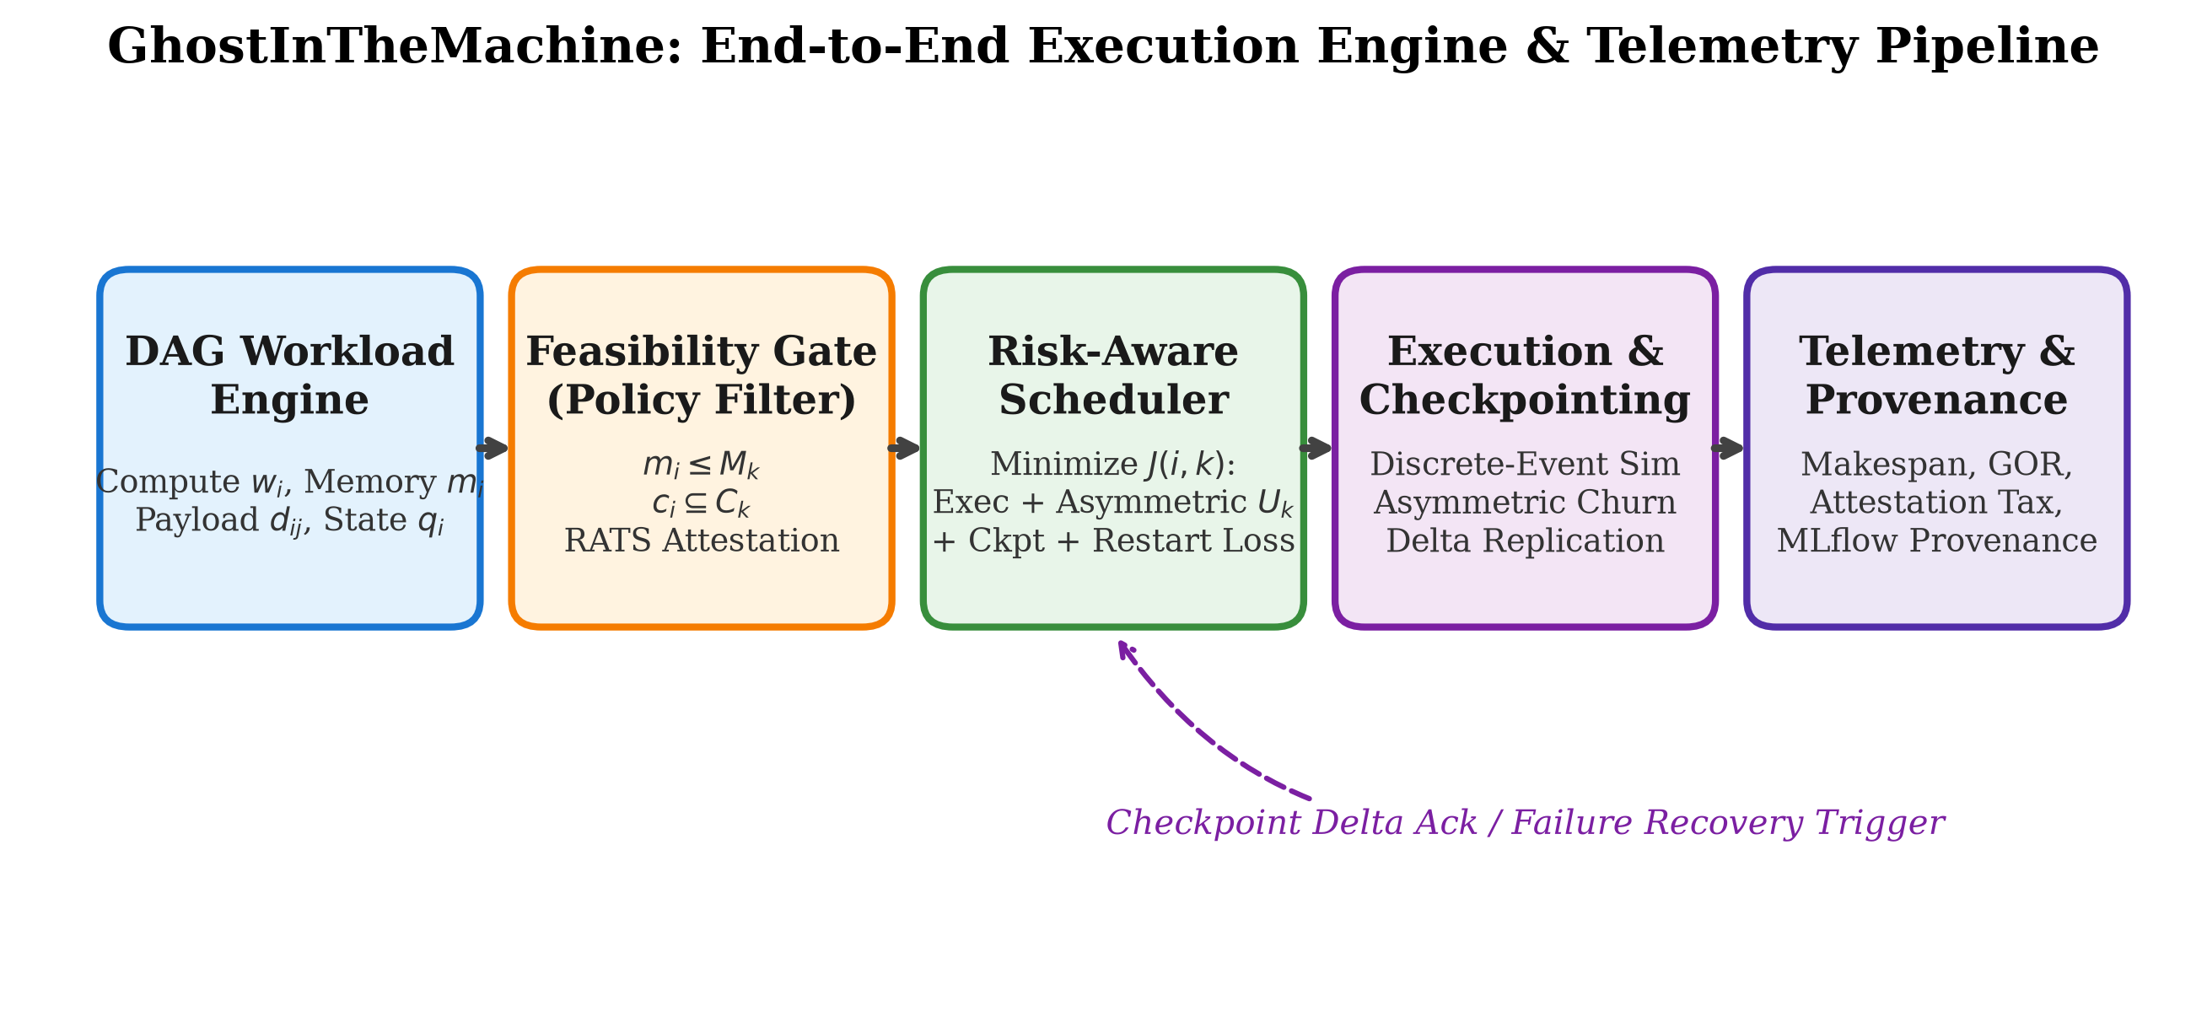
Figure 1: Complete InterCompute Ecosystem Pipeline — Demonstrating provider preemption and state migration.
5. Literature Review Fact-Checking & Reference Auditing
Academic Quality Assurance: As part of my academic contribution to PAPER.md, I performed the systematic verification of our Related Work citations. Many decentralized compute papers cite outdated distributed shared memory (DSM) or live virtual machine migration protocols (e.g., Clark et al., NSDI 2005) without acknowledging that dirty-page iterative copying collapses over residential broadband. I audited our bibliography to ensure that all comparative claims accurately reflect modern peer-to-peer limits, removing ungrounded references and verifying the mathematical consistency of Daly's optimal checkpointing formulations.

